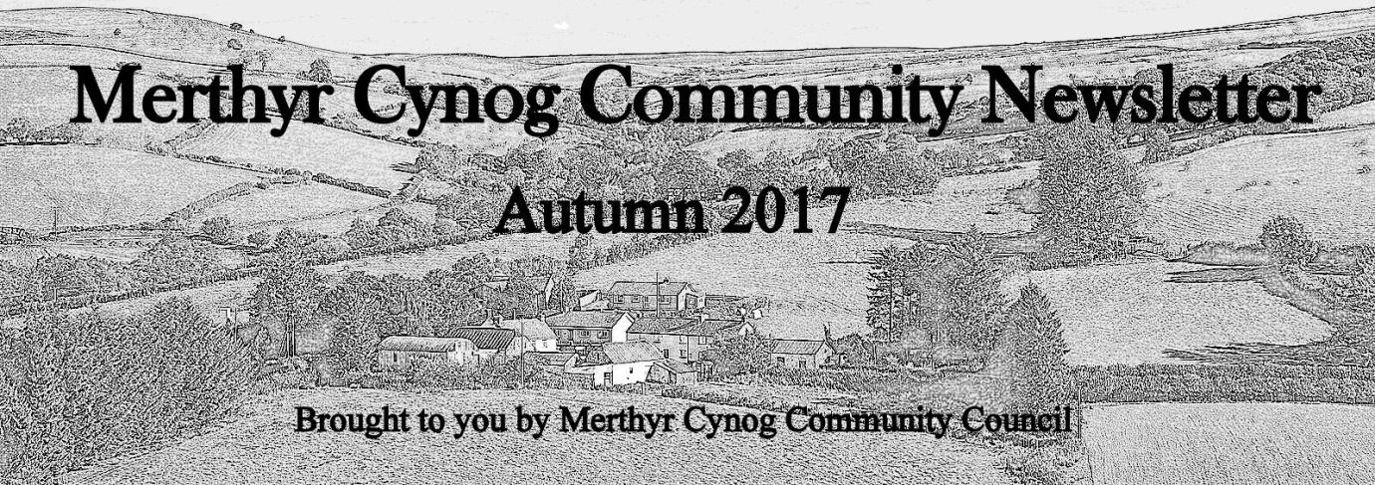

**Dates for Your Diary - The Community Hall**

* **Lip Sync Battle and BBQ –** Bring out your inner Britney Spears on **Saturday 28th October, 6.30pm.** In aid of repairing the hall’s boundary wall, mime along to your favourite song and be in with a chance of winning a fabulous prize. Let the Hall Committee know if you’re entering by 15th October and bring along your track on CD/MP3 on the night. For more information, contact Gaynor Morgan on Facebook or Chris Davies (690 342).
* **Community Bingo Evening –** Chance your luck on **Friday 24th November at 7pm.** Only £5 for a bingo book. A raffle and light refreshments will also be available. Don’t forget to bring your dabbers! For more information, please contact Annette or Lynne.
* **Senior Citizens’ Christmas Dinner –** Get together on **Monday 11th December, at 1pm**. The dinner, funded by Merthyr Cynog Community Council, is free for those of retirement age (and spouse) who live in the parish of Merthyr Cynog. To book a place, get in touch with Annette, Lynda or Lynne.
* **Ebenezer Carol Service –** Warm up your vocal chords for **Sunday 17th December at 3pm**. We will be joined by special guest, Father Christmas, following the service.

**Club News**

**Merthyr Cynog Womens’ Institute**

The WImeets on the first Tuesday of every month at around 7.15pm in the Hall. They are always happy to receive new members and you can even try several ‘taster’ sessions before actually joining. Meetings and guest speaker presentations are followed by refreshments and a chat.Coming up in the next few months are the AGM and sheep drive (**November 7th**), ‘Easy Christmas Decorations’ (**December 5th**) and bingo night (**January 2nd**).

**The Evergreens**

**Older members of our community can get together and socialise once a month as part of The Evergreens. They meet on the last Tuesday of every month at 2-4pm to play cards, have quizzes or enjoy ‘high tea’ and occasionally go out for dinner. There is no charge for the club and all expenses are met by a raffle. Anyone of retirement age is most welcome. Please contact** Annette (622 892), Lynda (625 133) or Lynne (690 260) if you want to know more.

**Badminton Club**

Badminton sessions have now re-started on a Friday night from 7-9 pm, for £2 per adult and £1 per child.  Anyone is welcome to these friendly and fun sessions for people of all abilities. Just come along to the hall to try it out or take it up again.

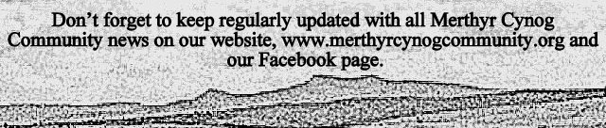

**County Councillor**

Our new county councillor, Iain Mcintosh, who was elected in June, has proposed to work on better internet and mobile phone connectivity in the Yscir ward. He is encouraging people to sign his petition for faster internet speeds, which he will be handing to the Welsh Government. If you would like to sign the petition or speak to Iain in general, call him on 07870655669.

**Community Council**

The Community Council meets every 6-8 weeks in the Hall. They aim to deal with any local queries or concerns you may have within the community. The Community Council also contribute to the running of the Community Hall, Pontfaen YFC, and the Evergreens Christmas meal. If you have an enquiry, please contact the council by e-mailing [merthyrcynogcc@yahoo.co.uk](mailto:merthyrcynogcc@yahoo.co.uk).

If you have news or an event that you would like to feature in the next Merthyr Cynog Community newsletter, please contact Kayleigh Jones at [joneskayleigh00@gmail.com](mailto:joneskayleigh00@gmail.com), phone 690 189 or get in touch with the Community Council.

**Community Hall**

The locals would like to thank the Community Hall Committee for organising another successful Harvest Supper on 7th October. It was the perfect occasion to catch up with friends and neighbours, whilst enjoying a delicious three course meal.

**Pontfaen Young Farmers’ Club**

The club kicked off the year with their annual general meeting, chaired by Jonathan Davies, who together with club leader Gaynor Morgan, congratulated the club on an excellent year.

The following were elected to office – President: Mr Richard Rees & Ms Kirsty Williams; Club Leaders – John Davies, Sue Price, Jan Healey, Gaynor Morgan, Caroline Frampton & Nicola Williams; Chairman – Vicky Price; Vice Chairman – Vicky-Lynn Healey; Secretary – Sian Healey & Molly Hennah; Treasurer – Rebecca Price; Minute Secretary – Emily Prothero; Press Reporter/Web – Vicky-Lynn Healey.

A few members have been travelling the globe this summer as part of Wales YFC’s Travel Programme. Sioned Davies and Sian Healey toured Europe on an inter-railing trip of a lifetime, taking them across 5 countries over two weeks, from the Czech Republic to Croatia. Kayleigh Jones also spent six weeks in Montana, USA, visiting national parks like Yellowstone and Glacier as well as living on a cattle ranch and experiencing life at an American fair and rodeo.

Many thanks to all attended the quiz night on 9th October. Much fun was had by members of the club and the surrounding community.

The club recently enjoyed a successful new members evening and were pleased to see many new faces. The club is going from strength to strength and welcomes anyone aged 10 – 26 to join up. For more information, please email [pontfaenyfc@gmail.com](mailto:pontfaenyfc@gmail.com) or come along to a meeting on a Monday evening at the Hall, 7.30pm.